Troy Meadows

Seth Hanusik

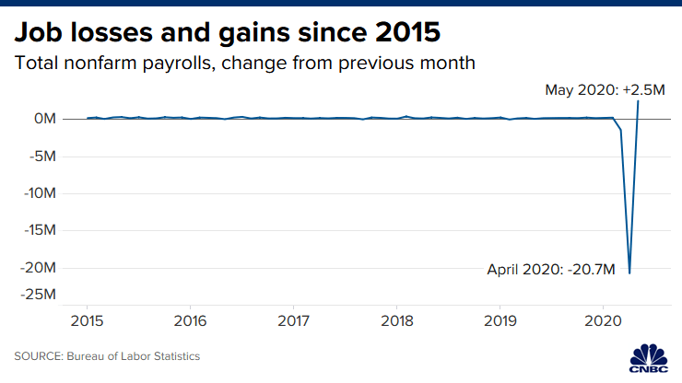1. Analyze the visualization

a. Data

* What is the dataset: Tabular? Network? Geospatial
  + tabular
* What data types are used: Nominal, Ordinal, Quantitative, Spatial, Links....?
  + Quantitative, Ordinal
* How was the data collected (if available)
  + Data collected by the Bureau of Labor Statistics, and the data is presented by CNBC

b. Visual representation

* How is the data visually represented?
  + Change over time
* What marks are used? Points? Lines? Shapes?
  + Line connecting points over time
* What visual channels are used? Position, Size, Hue, Orientation?
  + Position
* How are items positioned? Linear scales? Layout algorithm?
  + Linear and time scales

c. Interactions - No interactions for this visualization

* What interactions are available?
  + No interactions available - static visualization
* How do they change the representation?
* Do they use a UI? Direct manipulation on the chart?
* Multiple coordinated views? Brushing? Lenses? Details on demand?

2. Discuss the purpose of the visualization

* Who is it for?
  + General public? - presented by a public news source
* What can you learn from the visualization?
  + From April to May 2020, there was the largest gain in jobs -
* What can you learn from the interactions?
  + There aren’t any interactions, so there’s not much to learn

3. Critique the design choices

* Did they choose effective visual channels for communicating their data?
* What potential problems might arise with this visualization?
  + There is such a high peak in 2020 that it nullifies the rest of the data, almost making it a straight line
* Is this visualization misleading?
  + Yes, because most of the data is represented as so close to 0
* What could be done differently
  + Find a way to more accurately represent the data to scale. Add interactions to involve the user and show more detailed data.